**TASK 4.3**

pwd is not necessary because terminal shows current directory default.

**2. ls -l/ ls ls ~**

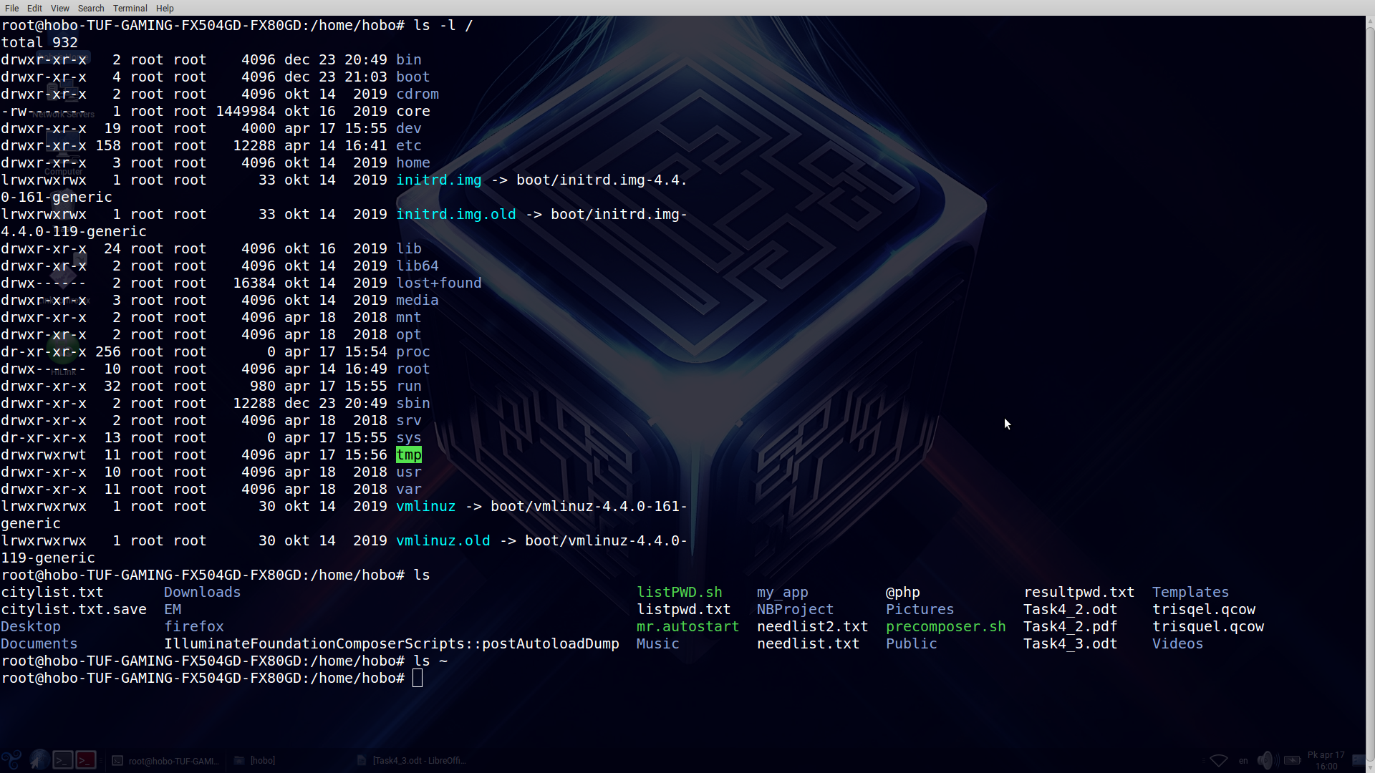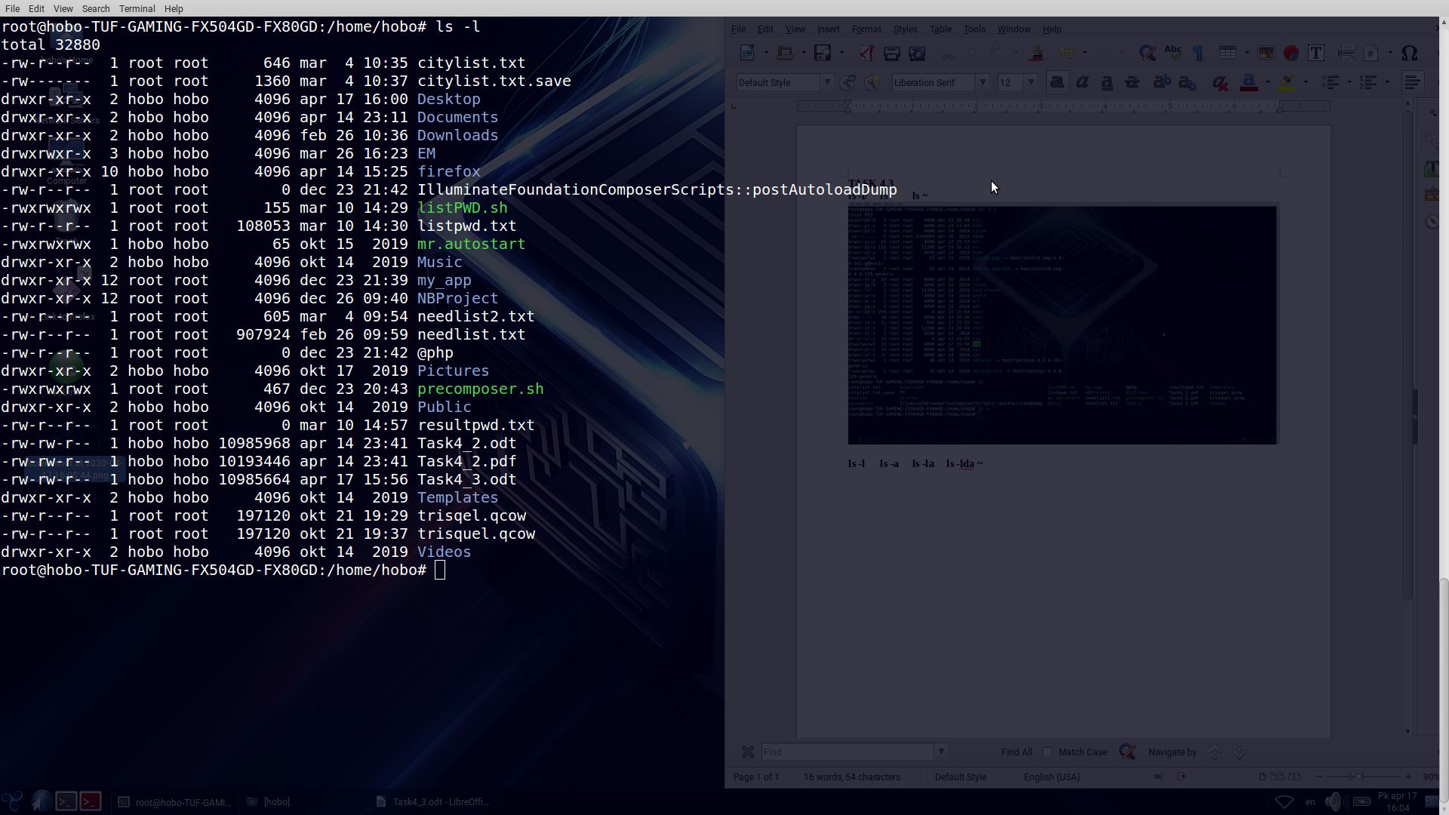

**2. ls -l**

**2. ls -a ls -lda ~**

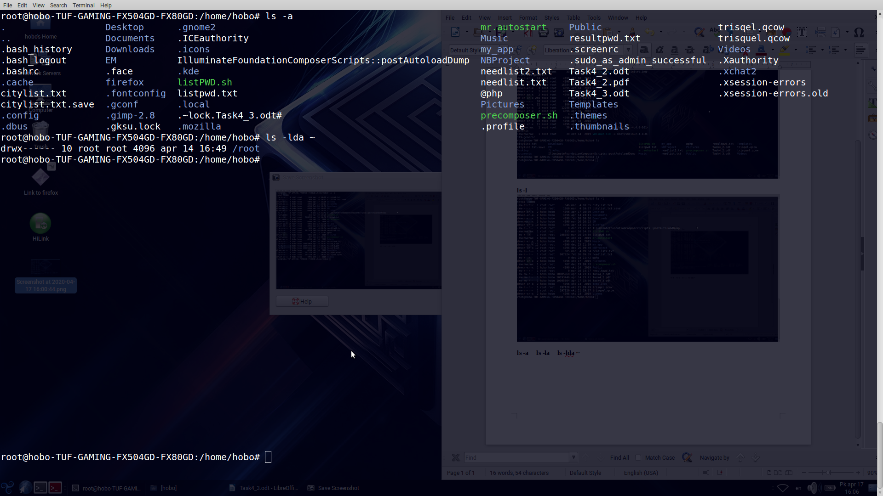

**2. ls -la**

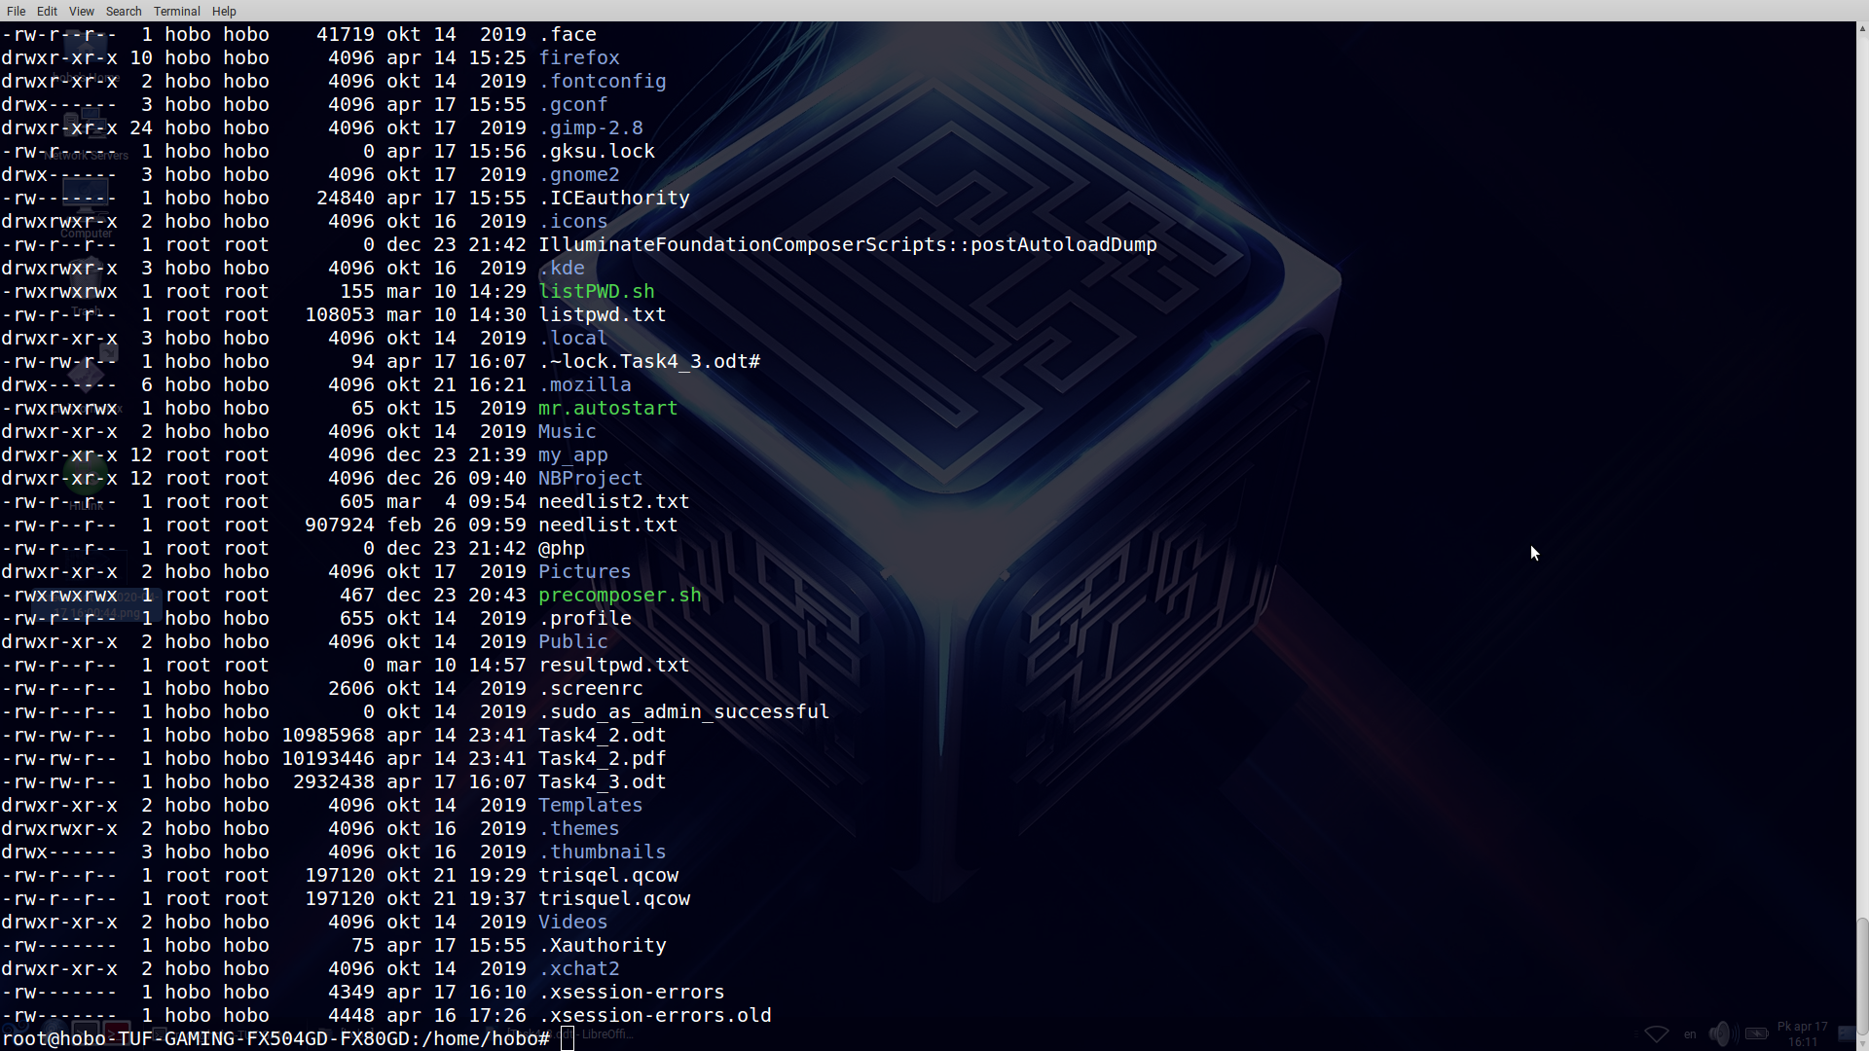

The command “**ls**” show names of files and folders in current directory which are public.

Key “**-a**” allows print all names of files and folders in current directory including hidden files.

Key “**-l**” allows print list of public files and folders with owners, groups, time of creation and other info of each file.

Key “**~**” show list of backup copies of files.

Combination of all of these keys like “**-la**” in command “**ls**” are possible.

**3.** Executing of commands and explanation

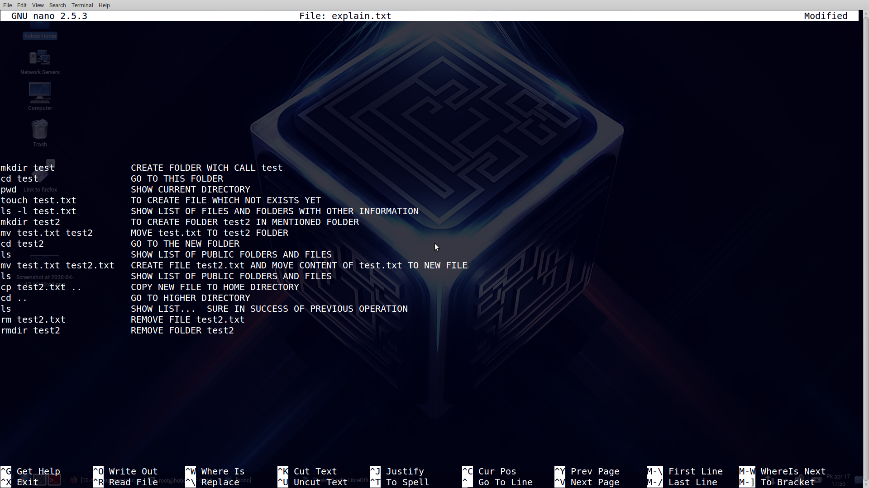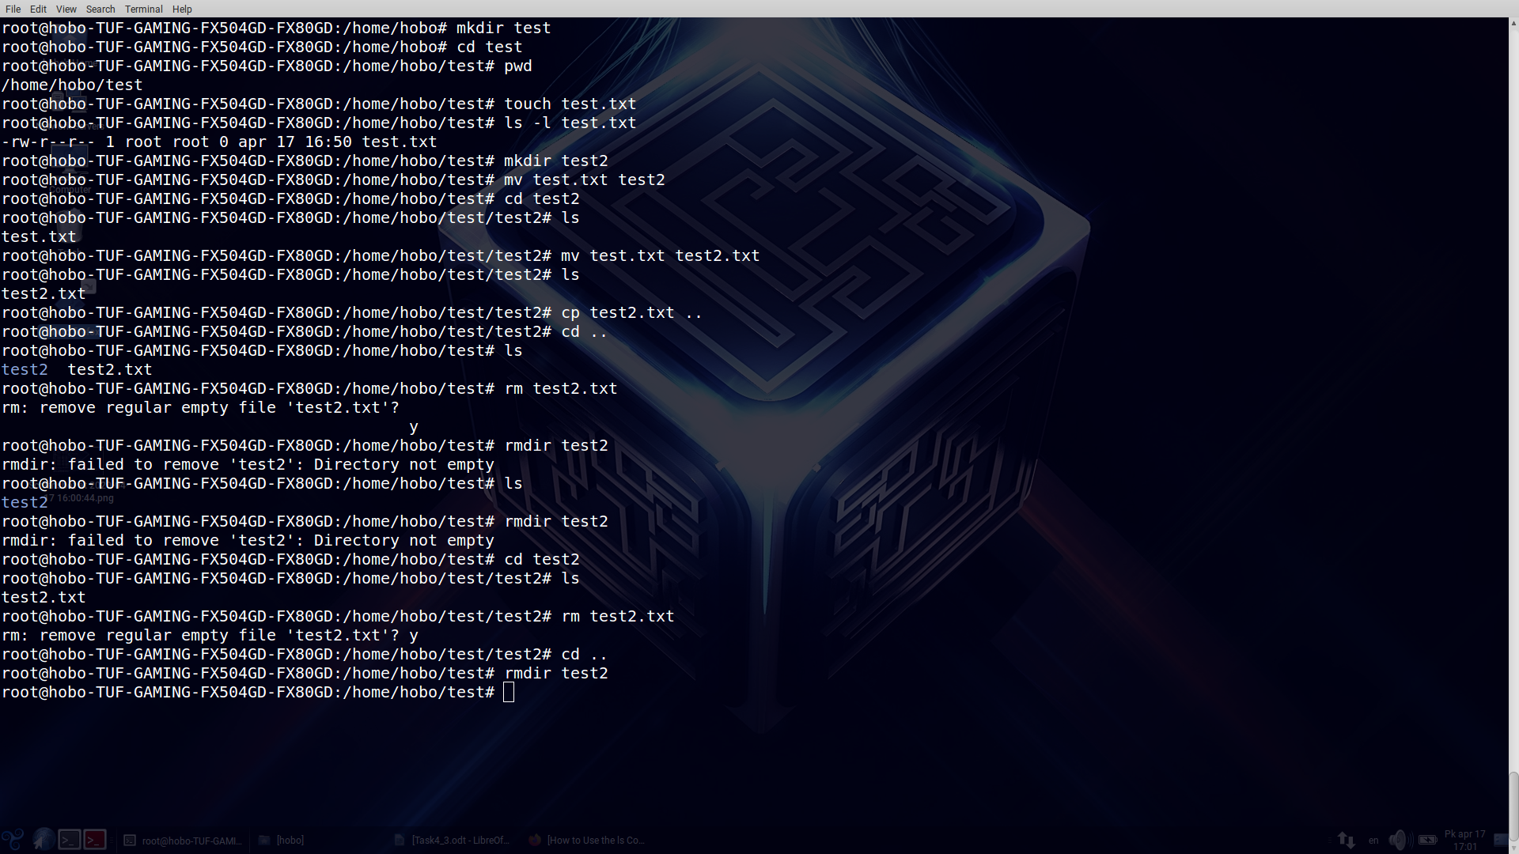

**4. cat more less**

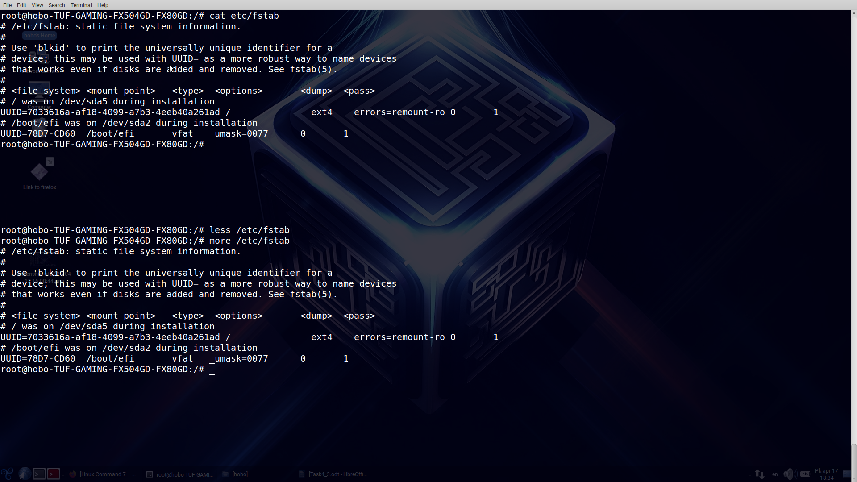

Command **cat** print all content of file

Command **less** allows to search string in the file. Has several ables from **vi**

Command **more** allows to print content page by page or go to the precise page.

**5. Adding&Extracting archives**

